Reading:
Section 6, Chapters 110 - Epilogue (133)

Overview
Chapters 110 - 130
Events become darkly ominous. Queequeg lies in his coffin. Note the imagery in 112, The Blacksmith, and 113, The Forge. The Pequod Meets the Rachel, 128, is a final reflection on Ahab's descent. Rachel is a Biblical allusion. Check the meaning on the Allusions2 List, Chapter 128.
Chapters 131 - Epilogue
Do you think the ending fanciful, totally not really possible? Actually, the possibility and reality of it happening in this way is told in tales of whalers and in their folk songs. Listen to a folk song based on a true story written in the 1840s by a sailor named Scammon. Tommy Makem sings.
The story of the sinking of the whale ship, Essex, as recorded by First Mate Owen Chase in 1821, was a best selling publication read by many, including a young Herman Melville. The ending of his novel is obviously similar to Chase's account.

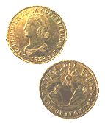

Congratulations!
You are now an Ishmael.
You may never pick up the novel again; you may take a break, then reread it entirely; you may go back to reread only certain chapters.

Youmay love the novel; You may hate the novel. Whatever. You started it. You finished it. You have bragging rights.

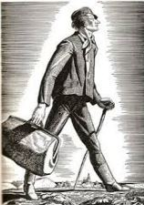

Review
Access the Review section here, from the Resources section, or from the right navigation link, when available.
Note: The Review is not intended for movie viewers, synopsis scanners, or comic book readers. Those who have read the book, beginning to end, should get some benefit if they wish to pursue an interpretive overview of the novel.

