Reading: Section 4
Chapters 66-86

Overview
Congratulations! You have finished one-half of this journey. Section 4 has high detail on various aspects of hunting and dissecting the whale. Do not become bogged down with the literal detail. The detail can be interesting and exciting, but Ishmael is trying to communicate the application of the literal details to human endeavors and the human condition. That it is what it is all about.
Consider Chapter 66. This short chapter describes the killing of sharks in high detail. But take note of the last paragraph. It gives insight into Queequeq's philosophy. What is it?
Chapter 68 describes the skin and blubber of the whale in great detail. Note the last paragraph--a direct elevation and application to humans. Ishmael learns from Nature:....Oh, man! admire and model thyself after the whale! Do thou too remain warm among ice....
Here are direct lessons, and Ishmael wants us to know them. This is Romanticism: We observe Nature and we learn about ourselves.
In Section 4 you will have two gams. The sailors enjoy the gams because it gives them an opportunity to visit with others and receive news from home. With each gam, make note of how Ahab acts and reacts.

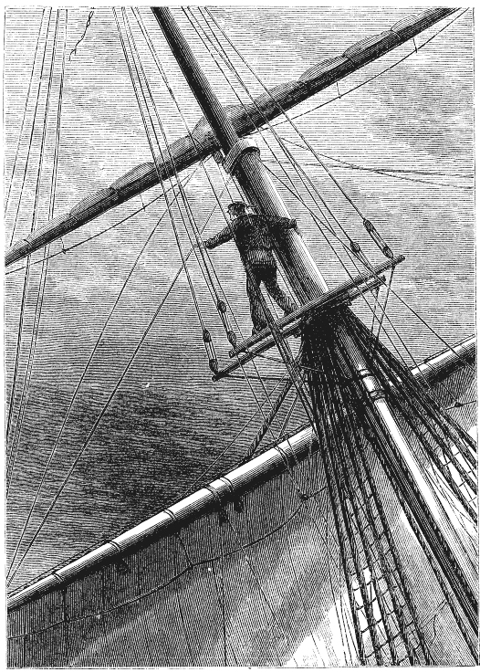

Lessons
The lessons that Ishmael learns and tries to communicate is why you are reading. Ralph Waldo Emerson said that a poet is one who experiences the transcendental and can communicate it to others in any manner. Ishmael has become a poet: He is now communicating lessons learned from Nature. He "sees behind the mask."
1. Read the following chapters for lessons/elevations (applications to humans or the human condition). They come at the end of the literal description. Specifically identify the literal to elevation:
- Chapter 69 The Funeral--the stripping of the whale.
- Chapter 70 The Sphynx--the beheading of the whale. Ahab teaches the lesson here (as observed by Ishmael).
- Chapter 72 The Monkey Rope--the cutting in (stripping the blubber) of the whale; also, the monkey rope itself.
- Chapter 75 The Right Whale's Head--a comparison with the Sperm Whale's Head described in Chapter 74. The lesson comes at the end of Chapter 75.
2. Suggested journal entry: Identify two descriptions of events or observations in your real life and a related elevation for each.

